GRACE CHURCH
ELECTED OFFICE
INFORMATION:

Warden, Vestry Member, Diocesan Convention Delegate/Alternate, Nominating Committee Member

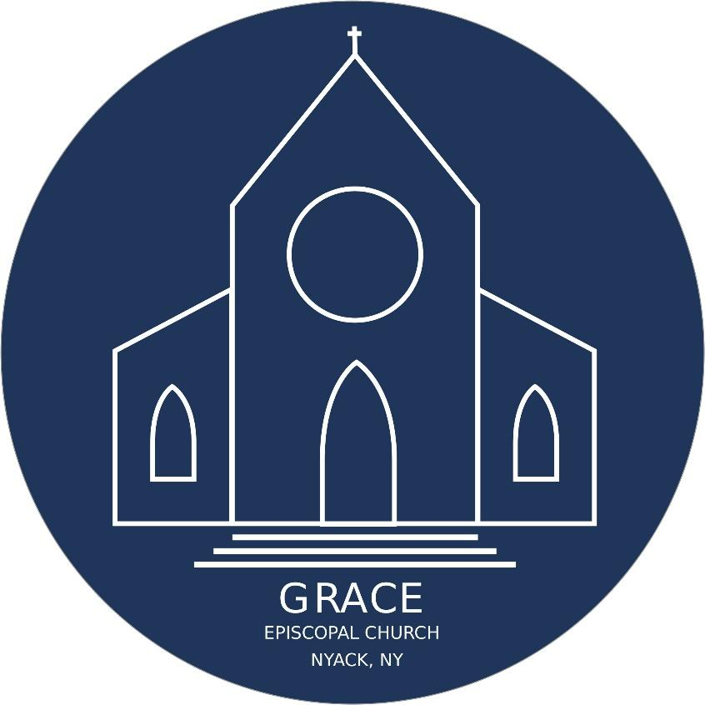

Elected office is a response to a call from God to offer a particular kind of leadership service to the Church. Perhaps you are hearing such a call for yourself, or sensing that call in someone else you’d like to nominate for an office. This document aims to assist Grace Church’s members in discerning those who may be called to lead in these particular roles, by highlighting the requirements, responsibilities, and expectations of elected office holders.

What is the mission of Grace Church? We believe that Grace Episcopal Church is called by God to live the way of Jesus through a ministry of reconciliation, seeking to restore all people to unity with God and each other, through prayer, worship, spiritual growth, witness and action

What are the qualifications for holding an elected office?
1. According to Grace Church’s by-laws, those eligible for election are baptized persons of the age of eighteen years or older, who have been active in the Eucharist (a minimum of three times a year), who claim Grace Church as their place of worship, and who have contributed to its mission for at least twelve months prior to the Annual Meeting. Additionally, potential vestry members and wardens must have been confirmed in or received into the Episcopal Church.
2. Potential elected leaders should already demonstrate regular participation in worship, mission, ministry, and leadership at Grace Church.
3. Potential elected leaders should also already tend to their spiritual lives with regular prayer, scripture reading, and a desire to be a good steward of their time, talent and treasure.
What are the primary responsibilities of the vestry of an Episcopal Church?
1. To take care of the parish finances
2. To take care of the parish buildings and property
(from The Vestry Handbook)
What are the expectations of Grace Church’s vestry members and wardens?
1. Mission Oriented. Vestry members will lead in identifying and carrying out the mission of the church.
2. Monthly Meetings. The vestry currently meets on the third Thursday of the month at 6:00 pm. Meetings generally last 2 hours. Members are expected to be available for every meeting, and to inform the clergy and the wardens if prevented from attending for good cause.
3. Vestry Retreats. Vestry members are expected to attend an annual vestry retreat.
4. Assuming Responsibility. Each vestry member will be expected to lead and incorporate others into ministry areas of their choosing, such as Christian Formation, Properties, Stewardship, Worship, and Pastoral Care.
5. Being an Example. As Christian leaders set apart for their service through the Church, vestry members will set an example for other members of Grace Church.
What are the primary responsibilities of Diocesan Convention delegate and alternate?
To represent the interests of Grace Church and the Diocese of New York by attending and voting in person at the Diocesan Convention on Friday, and Saturday, November 13-14, 2026.
What are the primary responsibilities of nominating committee members?
To identify and recruit members of Grace Church to fill vacant elected offices (vestry members, wardens, convention delegates/alternates, and nominating committee members) each year.

TERMS OF ELECTION: Vestry members are elected for a three-year term. The Wardens are elected for a two-year term. Diocesan Convention delegates/alternates and nominating committee members are elected for a one-year term.
WHEN ARE ELECTIONS HELD? Elections will be held at the Annual Congregational Meeting, Sunday, February 8th, 2026.
HOW TO SUGGEST A MEMBER FOR ELECTED OFFICE: Fill out the Expression of Interest Form below and turn it in to a nominating committee member, place it in the offering plate, or turn it into the office by Sunday, November 16. You may name yourself or someone else. A committee member will follow up with additional information.
EXPRESSION OF INTEREST:
After careful and prayerful reflection on the description of the requirements and expectations of each office, I believe that the following people should be considered in the pool of candidates for elected service at Grace Church:
(please specify the elected office(s) of interest for each name)

Turn the form into the church office, put it in the alms basin, hand it to Warden Emily Nevill, or submit it online, scan QR Code below or visit: www.gracechurchnyack.org/nominations2025 by Sunday, November 16th.


